Assignment No: 10

Title: Program for blinking of LED using Arduino Kit.

Objective:
To implement simple program using Open source prototype platform like Arduino for digital read/write using LED and switch Analog read/write using sensor and actuators.

Problem Statement: Write simple program using Open source prototype platform like Raspberry-Pi/Beagle board/Arduino for digital read/write using LED and switch Analog read/write using sensor and actuators.

Course Outcome:
C214455.IV: Use source prototype platform like Raspberry-Pi/Beagle board/Arduino Blooms Taxonomy Category: Applying

Input:
- Arduino kit
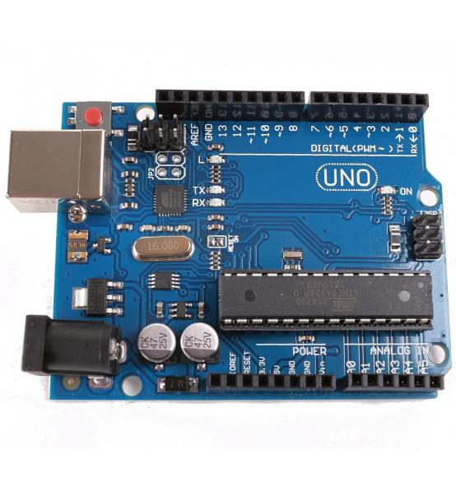

- Connection diagram (at actual image)
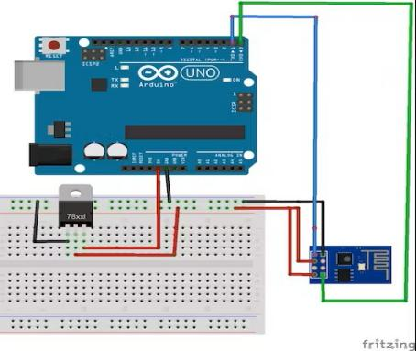

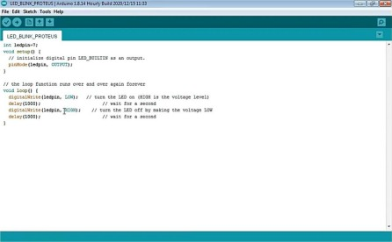
- Proteus connection diagram
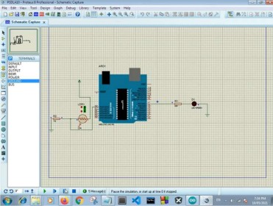

Output:
Proteus output window with blinking of LED.

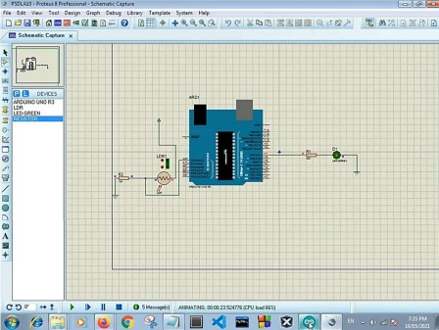
Inference: Thus we have successfully implemented simple program using Open source prototype platform like Raspberry-Pi/Beagle board/Arduino for digital read/write using LED

